


Semester: Fall…………………….… Academic Year: 2024…………….………...………….…

Course Title: Business Analytics Applications …………… ……………………………….…..……….…

Course ID: BANA600 …………………………………………………………………………..………….

Section Number: … … … … … … … … … … … … … … … … … … … … … … … … … … … … … … … … . … … . . . .

Number of Enrolled Students: 5…………………………………………………………….....................

Instructor Name: Dr. Omar Hujran………………………………………………………………………………..………...

Assessment Tool:* …Assignment 1………………………………………………………………………..….……...

Assessment Date: …15/9/2024…………………………………………………………………………………….…..

Student Name: |  |  |  | Omar A. Shakir Al-Faiadh …….………………………………………………………………………………………….
Student ID: |  | 201735167 …………………………………………………………………………………………………
S.  No. |  |  | Course Learning Outcome (CLO) |  |  | Maximu m Mark | Scored Mark
1 | CLO1 |  | Contrast the Business Analytics landscape through example applications in diverse real-world problems |  |  | 4
2 | CLO2 |  | Implement analytics techniques innovatively to real-world problems and data from diverse functional areas of business administration |  |  | 3
3 | CLO3 |  | Apply analytics models, methods, and processes, using state-of-the-art analytics software. |  |  | 3
 |  |  |  |  | Total | 10

The assignment description written by the instructor:

“Use the Iris dataset. The Iris flower dataset or Fisher's Iris data set is a multivariate dataset introduced by the British statistician, eugenicist, and biologist Ronald Fisher in his 1936 paper. The use of multiple measurements in taxonomic problems as an example of linear discriminant analysis.
The data set consists of 50 samples from each of three species of Iris (Iris setosa, Iris virginica and Iris versicolor). Four features were measured from each sample: the length and the width of the sepals and petals, in centimeters. Based on the combination of these four features, Fisher developed a linear discriminant model to distinguish the species from each other.

Attribute Information:

- sepal length in cm
- sepal width in cm
- petal length in cm
- petal width in cm
- class: -- Iris Setosa -- Iris Versicolour -- Iris Virginica

This assignment aims to explore the dataset by unsupervised learning (i.e. clustering Iris dataset using K-means, DBSCAN and Hierarchical Clustering).”

My report:

Introduction:
In this assignment, I will analyze the Iris dataset. This dataset includes the following variables:
- sepal length in cm
- sepal width in cm
- petal length in cm
- petal width in cm
- class: -- Iris Setosa -- Iris Versicolor -- Iris Virginica
I will apply 3 different methods of clustering such as K-Means using 3 clusters, Hierarchical clustering, and DBSCAN. Then, I will use Silhouette plot and scatter plot to figure out the best unsupervised model that could be used on this dataset. In this assignment, I will use KNIME platform to make the basic statistics and to make the models. I will show in this report the results and the insights that I was able to get.

-Perform summary and preliminary visualization.

According to KNIME (2022), some of the nodes that can be used to perform statistical summary and clustering visualization for the data are Statistics node, and scatter plot node. I also used Silhouette plot node on “class” column that would be useful in one of the next requests.

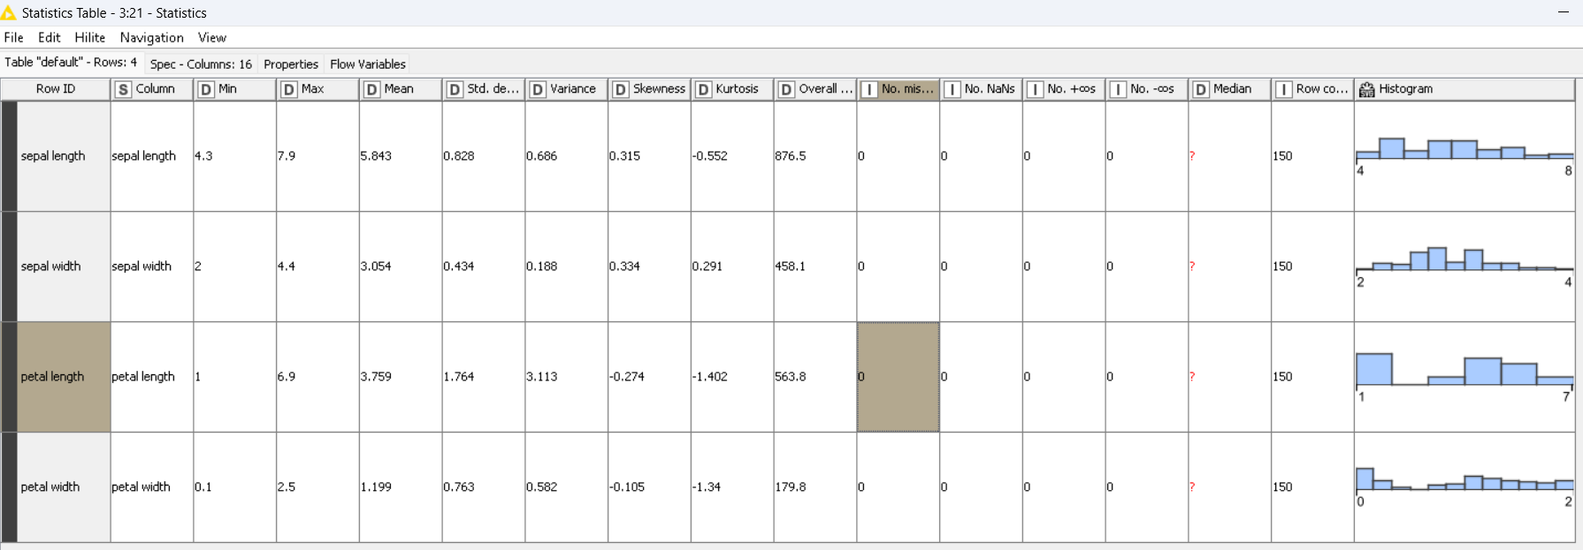
Figure 1: statistics table.

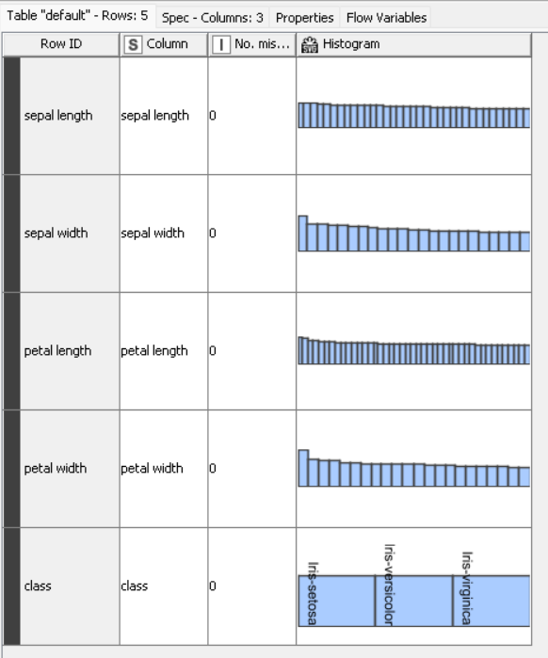

Figure 2: nominal histogram table.

In Figure 1 and 2, statistics node gave us basic statistics results about sepal’s width and length and petal’s width and length. It shows the minimum and maximum value of each one. And it also shows the mean, standard dev, variance, and other more statistics about them.

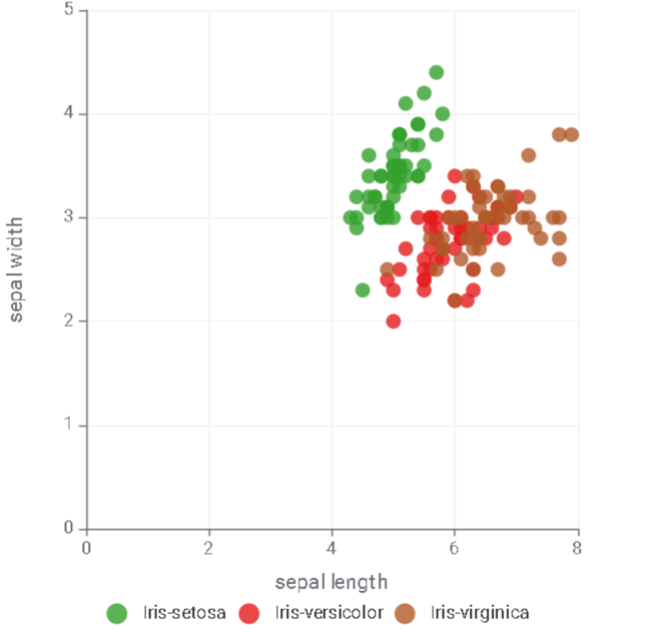

Figure 3: Scatter plot of “class”.

In Figure 3, we can see the scatter plot of “class” that shows Iris Setosa, Iris Versicolor, and Iris Virginica in 3 different colors, where the x-axis is Sepal Length, and the y-axis is Sepal Width. It shows the difference in sepal length and sepal width between the 3 types of iris where the colors are far enough from each other to make them look like 3 different clusters.

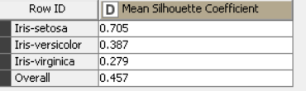

Figure 4: Mean Silhouette Coefficient.

In figure 4, we can see that the Overall Mean Silhouette Coefficient was 0.457. which shows a good coherence of the 3 types of iris but it is not high enough to say there is a major coherence between the 3 types of iris, where Dr. Omar mentioned in the class that the coefficient should be more than 0.5 to say that. This information will be useful later in one of the requests.

-Training k-Means model.

In KNIME, after normalizing the numerical attribute using normalizer node, I used K-Means node with setting the clusters to be 3.

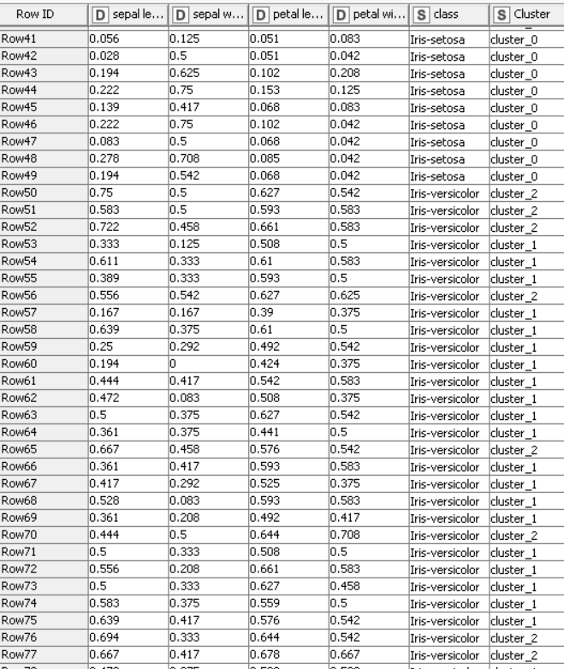
Figure 5: the data after dividing clusters into 3 different clusters.

In figure 5, we can see that a new column was added after using K-Means node. This column shows the cluster that each sample belongs to. cluster_0, cluster_1, and cluster_2.

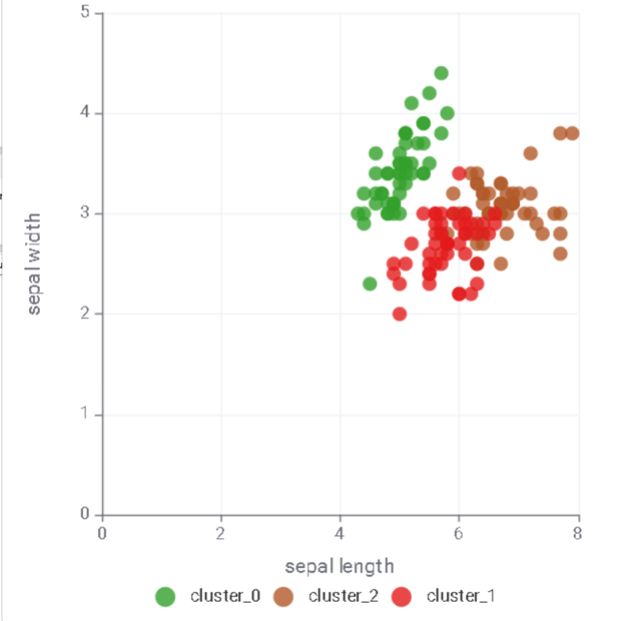
Figure 6: the Scatter plot of the K-Means clustering.

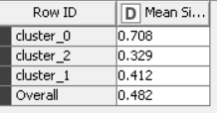
Figure 7: The Mean Silhouette Coefficient of K-Means clustering.

Figure 6 and 7 show the scatter plot of the 3 clusters and the Overall Mean Silhouette Coefficient of the K-Means clustering. The Overall Mean Silhouette Coefficient was 0.482, which shows that there is some kind of coherence between the clusters that K-Means method made. This coherence might be improved if we used other clustering method. We will see that by applying other clustering methods.

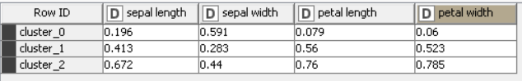
Figure 14: center of clusters

Figure 14 shows the centroids or the center of all 3 clusters that the K-Means model generated. It shows a 4-dimensional centers because the K-Means model used Sepal’s length and width and petal’s length and width in deciding for each point whether to be in cluster0, 1, or 2.
The center of the cluster: (sepal length, sepal width, petal length, petal width)
Cluster 0: (0.196, 0.591, 0.079, 0.06)
Cluster 1:(0.413, 0.283, 0.56, 0.523)
Cluster 2:(0.672, 0.44, 0.76, 0.785)

-Hierarchical Clustering.

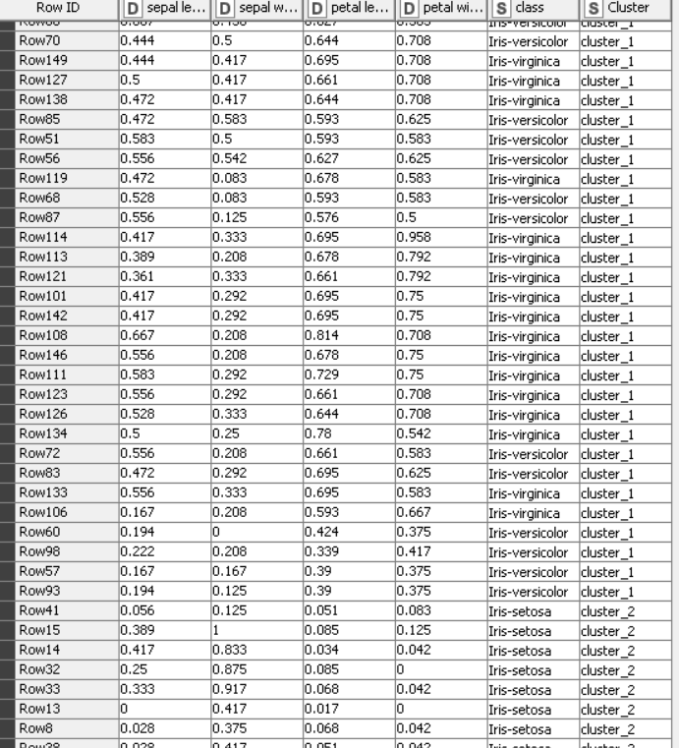

Figure 8: the dataset after applying Hierarchical clustering on the data.

I applied hierarchical clustering on the Iris data to get new clusters that might be better than the K-Means clustering method. The hierarchical clustering was set to generate 3 clusters. I used an Average Linkage method where According to Data Mining Map (2022)., it is the “average distance between each point in one cluster to every point in the other cluster.” The “clusters” column shows whether each sample was put in cluster_0, cluster_1, or cluster_2.

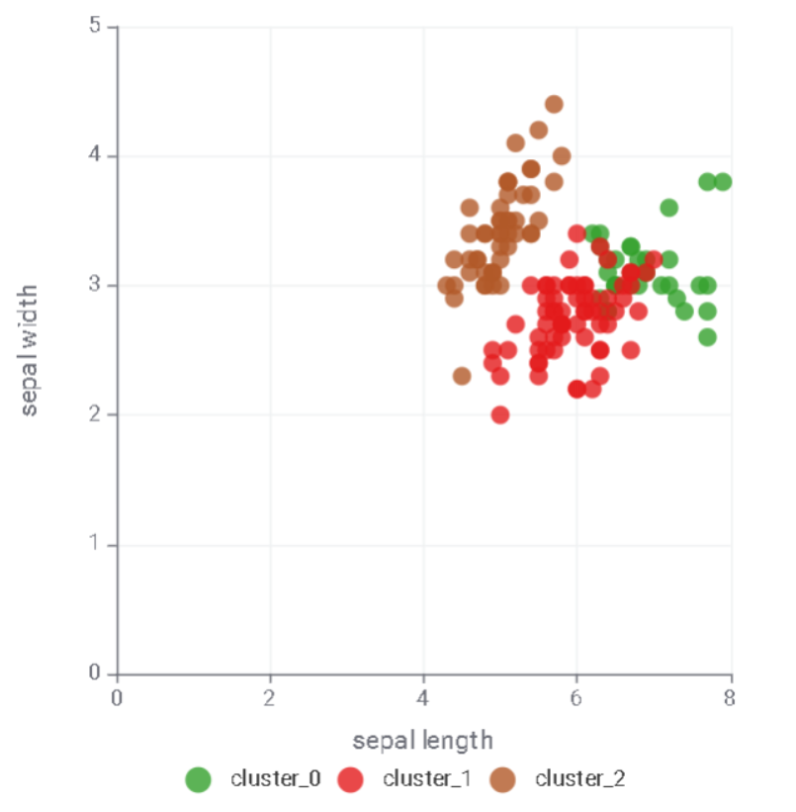

Figure 9: the scatter plot of the clusters of Hierarchical clustering.

This scatter plot shows the distribution of the 3 new clusters that was generated by hierarchical clustering method, where the x-axis is sepal length, and the y-axis is sepal width. We can see that the clusters are divided and there is coherence within each cluster. The next figure will measure this coherence.

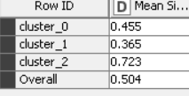
Figure 10: The Mean Silhouette Coefficient.

The overall mean silhouette coefficient was 0.504, which is more than 0.5, which shows that the clusters are separated well and shows high coherence. But we can test a third method of clustering to see if we’re going to have a better/higher result.

-DBSCAN Clustering.

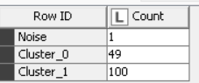
Figure 11: the count of each cluster and the noise made by DBSCAN.

Figure 11 shows the count of the repetitive of each cluster within the first 150 samples, after applying DBSCAN method. It shows that cluster_0 was repeated 49 times in the sample, while cluster_1 was repeated 100 times. There was 1 point that was considered as noise, which is a point that is too far to be considered part of any cluster.

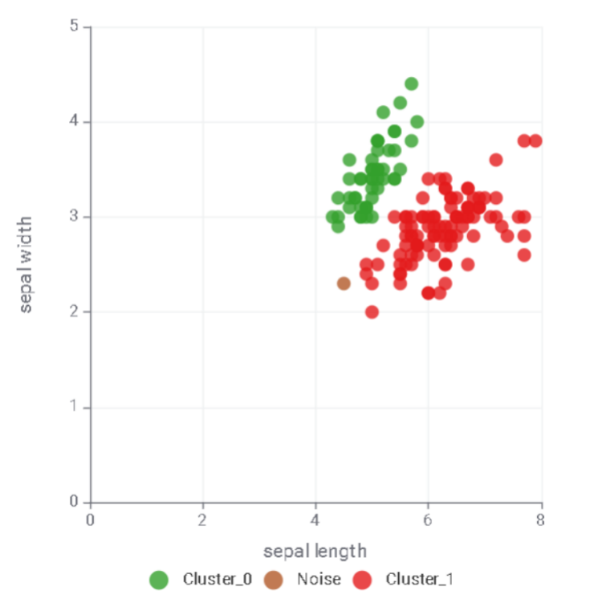

Figure 12: scatter plot of the clusters and noise of DBSCAN.

The scatter plot in Figure 12 shows how the points of each cluster are close to each other and how the clusters are separated. It shows that we have some noise in our result of DBSCAN, but the noise points are not that many.

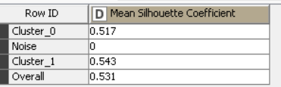
Figure 13: The Mean Silhouette Coefficient.

Figure 13 shows that the Overall Mean Silhouette Coefficient was 0.531, which is the highest result compared to the other 2 clustering methods that we used earlier. It shows high coherence within the clusters, and it also shows that clusters are well separated. But this clustering method was able to generate only 2 clusters with some noise. Reducing the epsilon by more than 0.5 might cause an increase in the noise which I avoided. Even though this clustering method had the highest coefficient, we cannot consider it as the best clustering method for this dataset because of the noise that could increase if we tried to get a 3rd cluster using this method.

- Comparing the result of the above methods (K-means, DBSCAN and Hierarchical Clustering).

Comparing the results of the overall Mean Silhouette Coefficients of the 3 clustering method that I used in this assignment. As we can see in Figure 7, 10, and 13, the results were as following:
K-Means clustering method: 0.482
Hierarchical clustering method: 0.504
DBSCAN: 0.531
This shows that DBSCAN was able to get the best clusters with the highest coherence and the most separated clusters. But at the same time, DBSCAN had some noise and had only 2 clusters, which is not the result that we’re looking for in this assignment. That’s why I would say that the Hierarchical clustering method would be a better choice to where it has 3 clusters, as we want, and it has a Silhouette coefficient higher than the K-Means method. The Silhouette coefficient of Hierarchical clustering method was high enough to say that the clusters are well separated, and its clusters have high coherence because its value is higher than 0.5. in conclusion, I would say that the Hierarchical clustering was the best method in my analytics (which might not be true if I used the same methods differently or on a different dataset)

Looking at Figure 3, 6, 9, and 12, We can see that the scatterplot of “class”, which is the types of iris we have, is similar to the scatterplots of K-means clustering method and Hierarchical method. The scatterplot of DBSCAN shows the different clusters than the types of iris in the scatterplot of “class”. Moreover, k-means clustering model and hierarchical clustering model both of them work well in distinguishing Setosa, which make both of them accurate, and having high accuracy in distinguishing Setosa. but the scatterplots also show that these 2 models are facing a slight problem in distinguishing all of the other 2 types of iris. Overall, the scatterplots of K-Means model and Hierarchical clustering model are much more accurate in distinguishing the types of iris than DBSCAN,

-References:

KNIME (2022, September 26). Know Your Data with Descriptive Statistics in KNIME. KNIME. Retrieved September 15, 2024, from https://www.knime.com/blog/know-your-data-descriptive-statistics

Data Mining Map (2022). Hierarchical Clustering. Retrieved September 15, 2024, from https://www.saedsayad.com/clustering_hierarchical.htm#:~:text=In%20average%20linkage%20hierarchical%20clustering,point%20in%20the%20other%20cluster.

